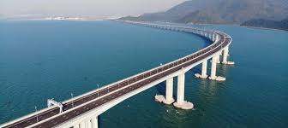**Bridge Hong Kong - Zhuhai – Macao**

Bridge Hong Kong - Zhuhai - Macao (HZMB: Hong Kong-Zhuhai-Macau Bridge) is a system of bridges, tunnels 55 km long including a series of three cable-stayed bridge, viaduct, tunnel under the sea and four islands artificial island. It is the longest sea route in the world, across the Lingding and Jiuzhou canals and connecting Hong Kong with Macau and Zhuhai, the three major cities to the west of the Pearl River Delta. HZMB was designed to last 120 years and was built at a cost of ¥ 126.9 billion (Unknown country code: China $ billion). The cost of construction of the main bridge is estimated at ¥ 51.1 billion (Unknown country code: China $ billion) financed by bank loans and shared among mainland Chinese governments, Hong Kong and Macau. The bridge was originally planned to open for traffic in October 2016, however by February 6, 2018 the structure was completed and journalists were on tour. mandarin. On October 24, 2018, Chinese President Xi Jinping attended the opening ceremony of the Hong Kong-Zhuhai-Macau Bridge at Zhuhai Port.